**Task 1**

1. Download Git from here <https://git-scm.com/> (Version 2.26.2)
2. Install Git (Installation Guide: <https://www.youtube.com/watch?v=SWYqp7iY_Tc>)
3. Create a Folder in Desktop with name “L3” and Right Click on folder L3 and **Select Git Bash Here**. You will see this screen

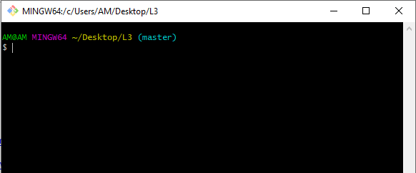

1. Check git version

* *git --version*

1. Now add files with this Command:

* *touch index.html*
* *touch about.html*
* *touch resources.txt*

1. Check your Folder, you will see these files

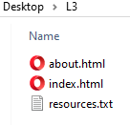

1. Open your file index.html in notepad or notepad++. Add these lines of code & save

*<html>*

*<head>*

*<title> My Title </title>*

*</head>*

*<body>*

*My First Page*

*</body>*

*</html>*

1. Open resources.txt and Write your name and Save this file
2. Initialize a Git repository/working directory
   * *git init*
   * Check your Folder, you will see .git folder. And within this folder you will find Git Related Folders and files.

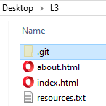

1. Configure user name and email
   * git config --global user.name ‘Your Name’
   * git config --global user.email ‘youremail@gmail.com’
2. Check Status of Working directory
   * *git status*
3. Add file or files
   * *git add index.html / git add .*
   * *git add .*
4. Check Status of Working directory
   * *git status*
5. Commit chages in your working directory
   * *git commit*
   * *git commit –m “Some git commit message”*

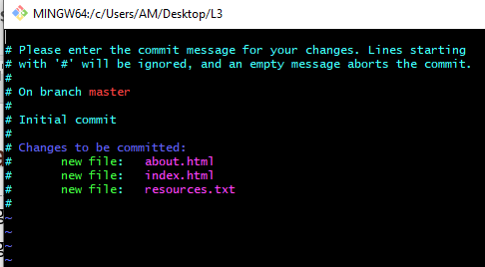

* + - Press ‘i’ to enable insert mode & type some text like *Initial Commit or any text*
    - *To Exit - Press ‘Esc’ Key and type ‘:wq’*

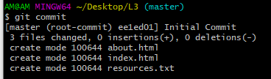

1. After all commit, Check Status of Working directory (This will show you message like nothing to commit, working tree clean)
   * *git status*
2. Make changes to resources.txt. Add few names of your friends
3. Check with git status, it will show (changes not staged for commit)
   * *git status*
4. Add file or files
   * *git add .*
5. Commit chages in your working directory with commit message
   * *git commit -m ‘Changed resouces.txt’*
6. Check with git status, it will show (changes not staged for commit)
   * *git status*
7. View commit history
   * *git log*

**Task 2 – Git & Github**

* + - 1. Create an account on Github.com
      2. Use Git Bash and Follow these commands:
         * *git remote*
         * *git remote add origin* [*https://github.com/youraccountname/reponame.git*](https://github.com/youraccountname/reponame.git)

*Ex - git remote add origin https://github.com/amaharjantbc/L3Sample.git*

* + *git remote*
  + *git push -u origin master*

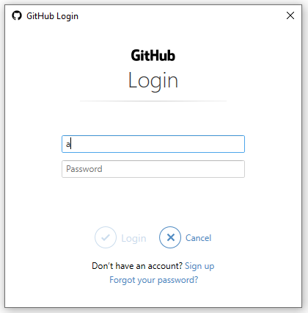

Enter your github username/email and password

Then in github.com, reload your repository page & see your added files

3. Clone Github Repository

* + - * + *git clone* [*https://github.com/youraccountname/reponame.git*](https://github.com/youraccountname/reponame.git)

**Task 3 – Branch & Merge**

**Task 4 – GUI**